**STARTER HINTS:**

int marksArr1[3][2]; // only declaring a 2D array, number of rows: 3, number of columns: 2

int marksArr2[3][2] = { {7, 8}, {9, 3}, {5, 7} }; // declaration and initialization using initializer list

marksArr2[0][0] = 10; // change element at 1st row and 1st column (previously 7)

printf(“%d”, marksArr2[1][1] = 10; // display element at 2nd row and 2nd column (value = 3)

**Problem 16-1**

1. Consider the following sequence of numbers:

1, 2, 3, 4, 5, 1, 2, 3, 4, 5, 1, 2, 3, 4, 5, 1, 2, 3, 4, 5, 1, 2, 3, 4, 5, 1, 2, 3, 4, 5

Using the above numbers sequence, declare and initialize arrays of following sizes. (Tip: copy paste above data to save time.)

1. 2 x 15
2. 3 x 10
3. 6 x 5
4. Declare and initialize following 2D array with name tableOfNums.

|  |  |  |  |  |
| --- | --- | --- | --- | --- |
| 1 | 5 | 2 | 9 | -2 |
| -5 | 10 | 5 | 66 | 1 |
| 0 | 0 | 56 | 6 | 7 |
| 89 | -15 | -11 | 0 | 25 |

Complete the following tasks for the above array.

1. Display last element of array.
2. Change element with value 56 to value 37.
3. Display 3rd row of array **WITHOUT** **USING** loop. (Hint: specify row and column index of each element to display in the 3rd row)
4. Display 3rd row of array **USING** loop. (Hint: row index fixed: 2, column index: loop counter)
5. Display last column of array **USING** loop. (Hint: column index fixed: 4, row index: loop counter)
6. Display whole array using a nested loop.

**Program 16-2**

**Program Name:** Sum the elements of a 2 dimensional array.

**Program Purpose:** Using multiple-subscripted (2 dimensional) array along with nested loop

**Problem Statement:**

* Write a program which declares an uninitialized 2D array of size 3x3.
* The values of the array are input by the user at run-time (see sample output).
* After inputting the array values, show the sum of all the elements in the array. (CAUTION: Display sum after the loop, not inside the loop)

**Hints:**

1. Outer loop controls rows counter, inner loop controls columns counter. The elements of the array are accessed inside inner loop.
2. Use the running sum pattern (sum initially 0 and accumulates each array element )

**Sample Output:**

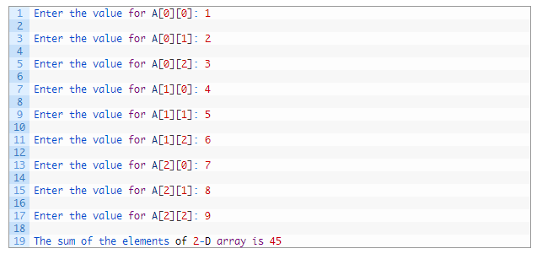

**Home Task 16-3**

**Program Name:** Sum 2 matrices using nested loops

**Program Purpose:** Using multiple-subscripted (2 dimensional) array along with nested loop

**Problem Statement:** Write a program which declares 2 arrays of size 3x3. Each of these array represent a matrix containing following values.

Matrix 1: $\left[\begin{matrix}91 & 2 & 3 \\ 5 & 11 & 0 \\ 5 & 1 & 20\end{matrix}\right]$

Matrix 1: $\left[\begin{matrix}0 & -1 & -8 \\ 45 & 1 & 2 \\ 5 & 7 & -7\end{matrix}\right]$

Write down a program to compute another matrix that is sum of the two above matrices. Finally, display the summation matrix.

**Hint:** Declare another matrix of the same size. Compute sum of element at each position of the input matrices and store at corresponding position in the third matrix. The sum will be computed inside a nested loop. Outer loop controls rows counter, inner loop controls columns counter. The contents of matrices (all three matrices) are accessed inside the inner loop. The matrix printing will also be performed in nested loop. Use separate nested loop for this to avoid confusion.

**Sample Output:**

